**Project Design Phase-I**

**Problem Solution Fit**

|  |  |
| --- | --- |
| Date | 30 September 2022 |
| Team ID | PNT2022TMID15971 |
| Project Name | Hazardous Area Monitoring for Industrial Plant powered by IoT |
| Team Members | Devadharshini S, Amancharla Vishnupriya, Dandolu Sujitha, Aruna V R |

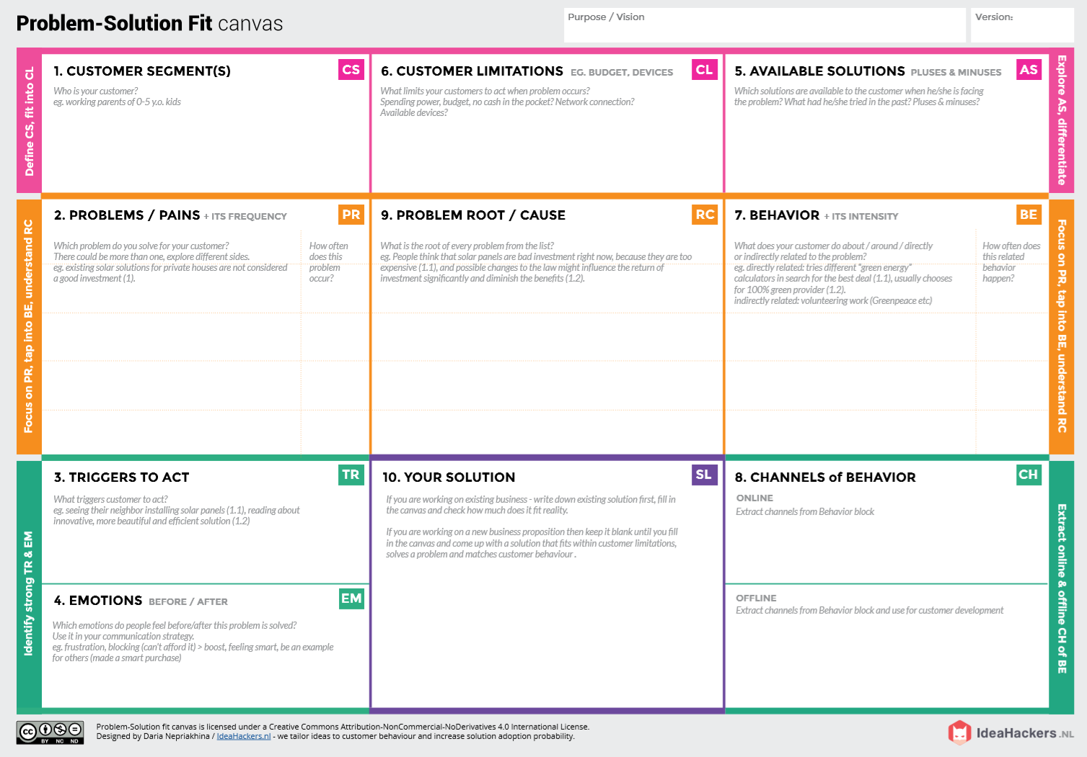

Develop an efficient system & an application that can monitor and alert the workers.

When the workers failed to monitor the area properly, the chemicals can cause high risk to their health or the properties of the industry.

Through newspaper advertisements.

Promoting through social media. With the help of social media entrepreneurs/influencer.

* Using manpower as the source of monitoring the industrial area causes high hazards.
* If the chemicals leaked is heavily toxic, there is a chance of causing hereditary health issues too.

The monitoring of area could be done by the manpower. Even though man power could reduce electricity cost and monitor properly, it may cause high risk for their life. There is also a cause of some errors due to manpower.

High budget in installing other products make them to move far from modern technologies.

**Before:** The heavy losses due to not monitoring the area properly made them feel of guilt due to reduced reputation of their products.

**After:** Increased the level of confidence and feel secured

The heavy damages or higher health issues due to hazardous area urges them to find out a solution as soon as they could possible.

* Damages that occurs in hazardous areas can result in the loss of property or lives
* Having no proper system for controlling or monitoring the area.
* Facing heavy budget problems in buying and installing a system for monitoring and controlling.

The industrialists who use hazardous chemical for their manufacturing.